Table of Contents

1. Introduction 2

2. System Overview 2

3. System Architecture 2

4. Data Design 2

5. Color Theory in System Development 2

5.1. Color Spaces 2

5.1.1. Munsell Color System 2

5.1.2. Additive Color System 4

5.1.3. Subtractive Color System 4

5.1.4. HSV Color Space 4

5.1.5. LAB Color Space 4

6. Component Design 9

6.1. Extract Color Theme from Images 9

6.1.1. median-cut algorithm 9

6.1.2. octree algorithm 10

6.1.3. kmeans algorithm 10

7. Human Interface Design 10

8. Requirements Matrix 10

9. Appendices 10

# Introduction

# System Overview

# System Architecture

# Data Design

# Color Theory in System Development

## Color Spaces

### Munsell Color System

#### Introduction

In [colorimetry](https://en.wikipedia.org/wiki/Colorimetry), the Munsell color system is a [color space](https://en.wikipedia.org/wiki/Color_space) that specifies [colors](https://en.wikipedia.org/wiki/Color) based on three color dimensions: [hue](https://en.wikipedia.org/wiki/Hue), value ([lightness](https://en.wikipedia.org/wiki/Lightness_(color))), and [chroma](https://en.wikipedia.org/wiki/Colorfulness" \o "Colorfulness) (color purity).

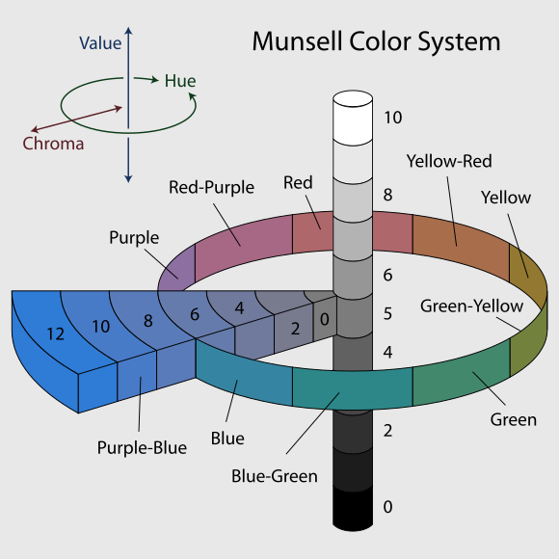

Figure 1 Munsell color system

As Figure 1 shows, in three color dimensions, the horizontal circle stands for hue, and each hue circle is divided into 5 hues (red, yellow, green, blue and purple), along with 5 intermediate hues (e.g., yellow-red).

The second element which represents lightness is value in the vertical dimension, from black (value 0) at the bottom to white at the top (value 10). Neutral grays lie along the vertical axis between black and white.

Chroma, measured radially from the center of each slice (each hue), represents the “purity” of a color, with lower chroma being less pure. Different areas of color space have different chroma ranges. For instance, there are more potential chroma coordinates of light yellow colors than those of light blue colors. The reason why this happens is the nature of our eyes and the physics of color stimuli. The human eye is an organ which reacts light and pressure.  Rod and cone cells in the retina allow conscious light perception and vision including color differentiation and the perception of depth.

The human eye can differentiate between about 10 million colors, but it is impossible to make physics objects in such numbers of colors, and they cannot be reproduced on current computer displays. Vivid solid colors are in range of approximately 8.

#### Visual Analysis -- Color Harmony Types

There are four color harmony types based on Munsell color system, complementary, analogous, monochromatic and diad. These four types focus on the color wheel which is based on hue in Munsell color system.

The figure below (Figure 2) shows 40 standard Munsell hue circle hue divisions.  The color wheel is measured off in one hundred compass points resulting in 100 steps on the hue circle.

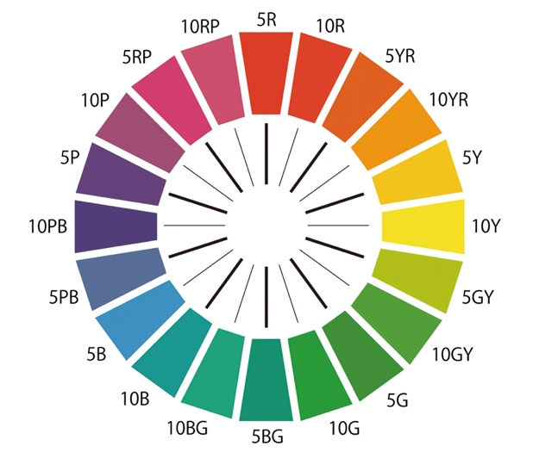

Figure 2 color wheel in Munsell color system

##### complementary color harmony

In the complementary color harmony type, we can say the two colors in the opposite position in the color wheel are harmonious. For instance, in Figure 2, the combination of 5R (red) and 5BG (bluegreen) is harmonious because 5R and 5GB are complementary colors.

##### analogous color harmony

Three colors adjacent to each other are defined as analogous color harmony. To be more specific, 5R, 10R and 5YR in the color wheel can be used to create a harmonious color theme.

##### monochromatic color harmony

Monochromatic color harmony only uses one hue with various tints, tones and also shades. We define

1. tint: hue color adding white color;
2. tone: hue color mixed with gray;
3. shade: hue color with black color

Based on the definition, we can know that hue-value combinations are regarded as a harmonious monochromatic color harmony.

##### diad color harmony

In the diad color harmony, we can choose two colors apart on the color wheel randomly, like 5Y and 5YR, which is the easiest way to apply.

### Additive Color System

#### Introduction

In the additive color system, all the colors are the mixtures of some light colors. Red, green and blue are the most common primary colors used in the additive color system, which is known as RGB color model. RGB is a method of presenting colours electronically by projecting light rays unto screens, such as TV or computer screens. Each light ray has its unique wavelength that creates a specific colour.

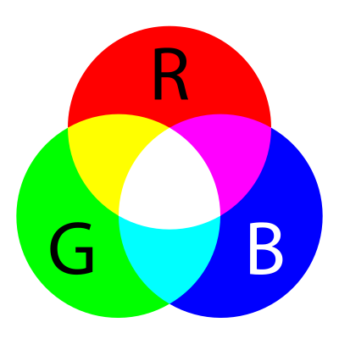

Figure 3 RGB color model

As Figure 3 shows, any two of standard additive primary colors (red, green and blue) combine into secondary colors, which are yellow, cyan and magenta.

Additive color is a result of the way the eye detects color and is not a property of light. There is a vast difference between a pure spectral yellow light, with a wavelength of approximately 580 nm, and a mixture of red and green light. However, both stimulate our eyes in a similar manner, so we do not detect that difference, and both are yellow light to the human eye.

#### Visual Analysis – Color Harmony

### Subtractive Color System

#### Introduction

### HSV Color Space

#### Introduction

### LAB Color Space

#### Introduction

#### Visual Analysis – Color Harmony

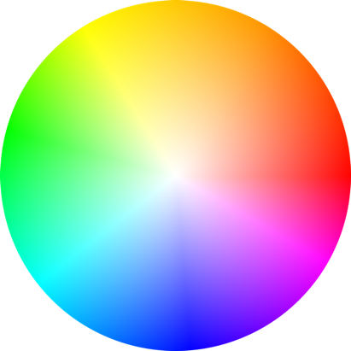Technically the color wheel shown below in Adobe Illustrator has most similarities with LAB color wheel but more visually.

Figure

There are 23 color harmonies built in Adobe Illustrator, and the majority of color harmony types are same as those in Munsell color system. I will only show those different ones.

##### complementary color harmony

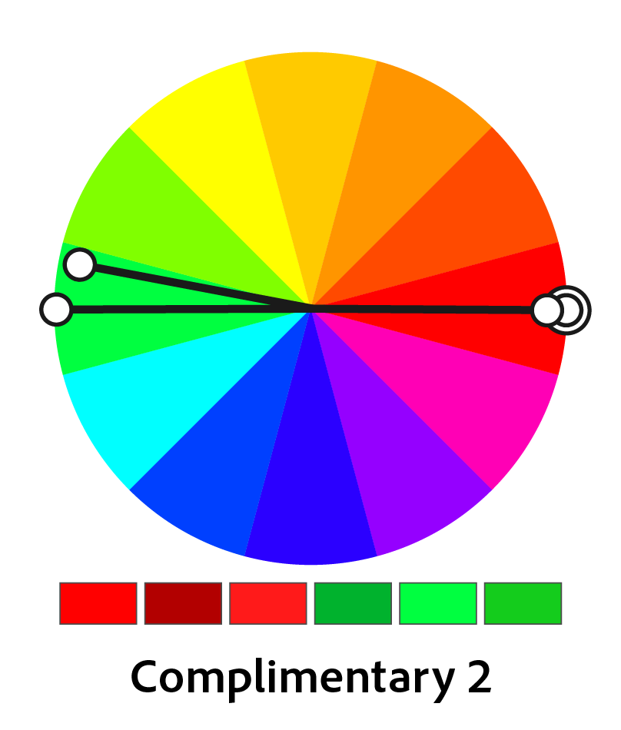

Figure

In addition to the original complementary color harmony, we can add one brightness and one saturation variant on the original color, and also the same to the complementary color, so we can have a harmonious color scheme with 6 colors.

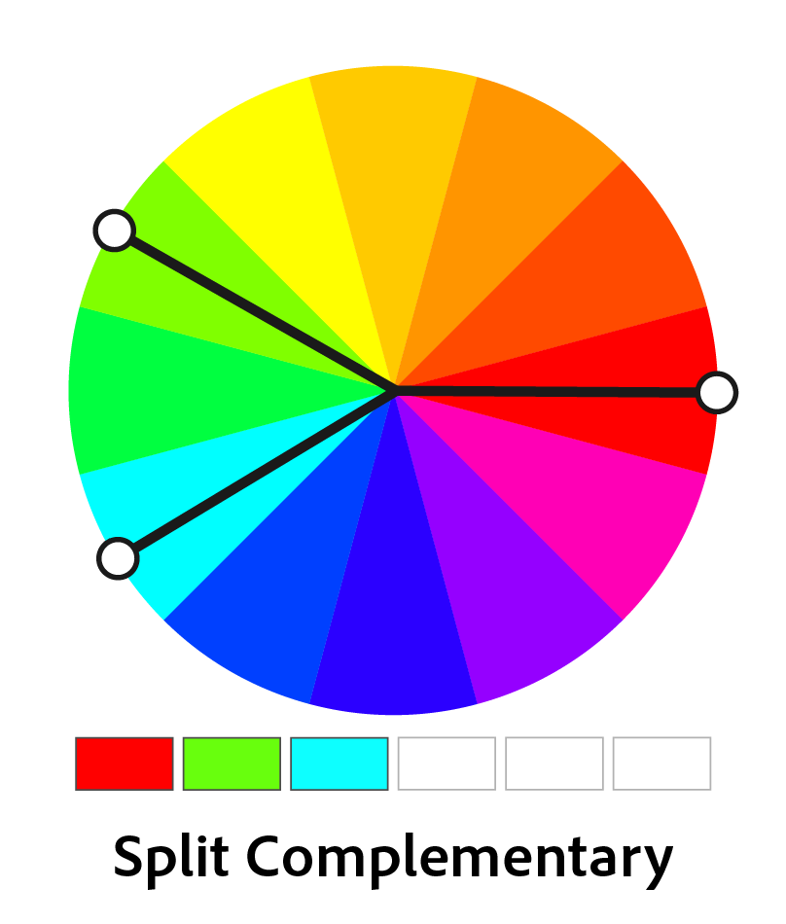

Figure Split color harmony

For the split complementary color rule, we split off one of original complementary colors by 30 degrees clockwise and counter-clockwise to produce 3 colors.

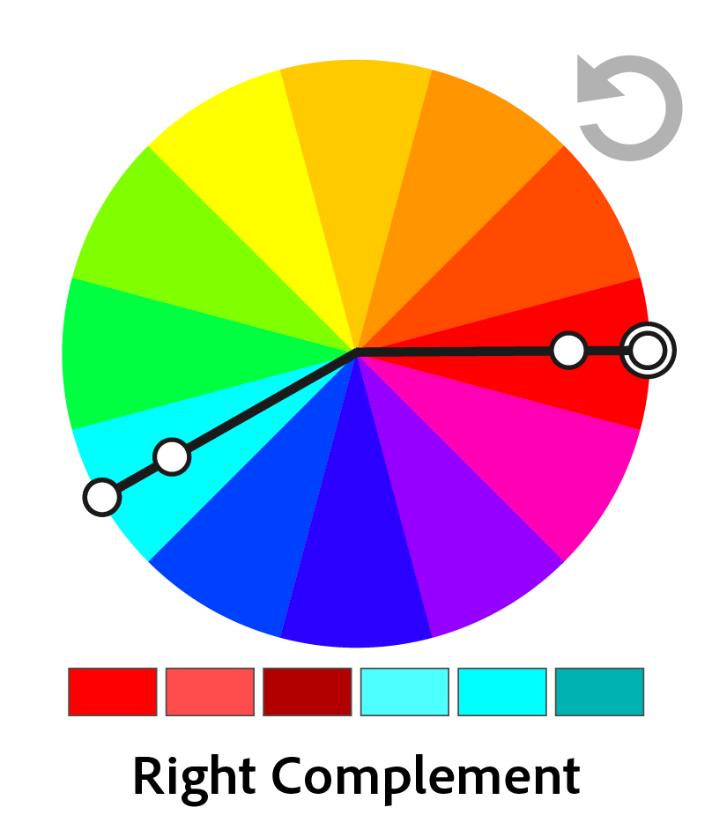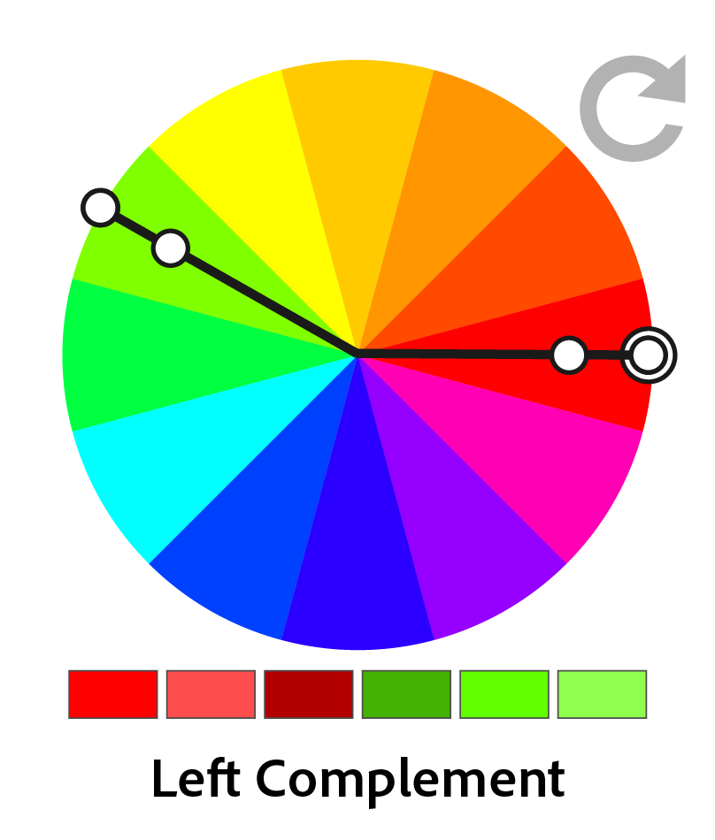

Figure Left Complementary Color Harmony Figure Right Complementary Color Harmony

Left and right color harmonies are two variations bend complementary color rules, with counter-clockwise and clockwise separately. we then add brightness, saturation shifting to the color schemes.

##### Analogous Color Harmony

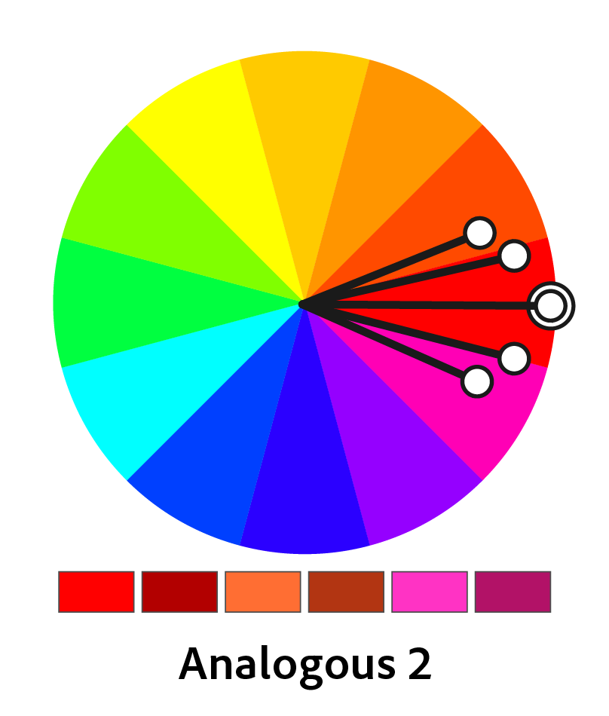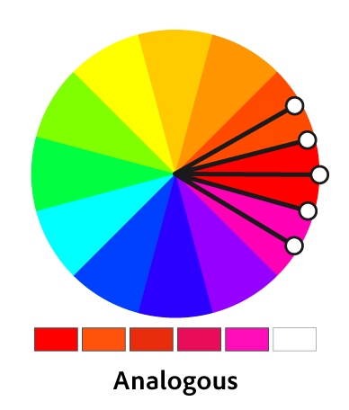

The analogous color harmony rule goes to shift the original color by 15 or 30 degrees with deeper saturation and brightness.

##### Triadic Color Harmony

In the color wheel, we split off the original color by 120 degrees, and then those 3 colors are called a triadic color harmony.

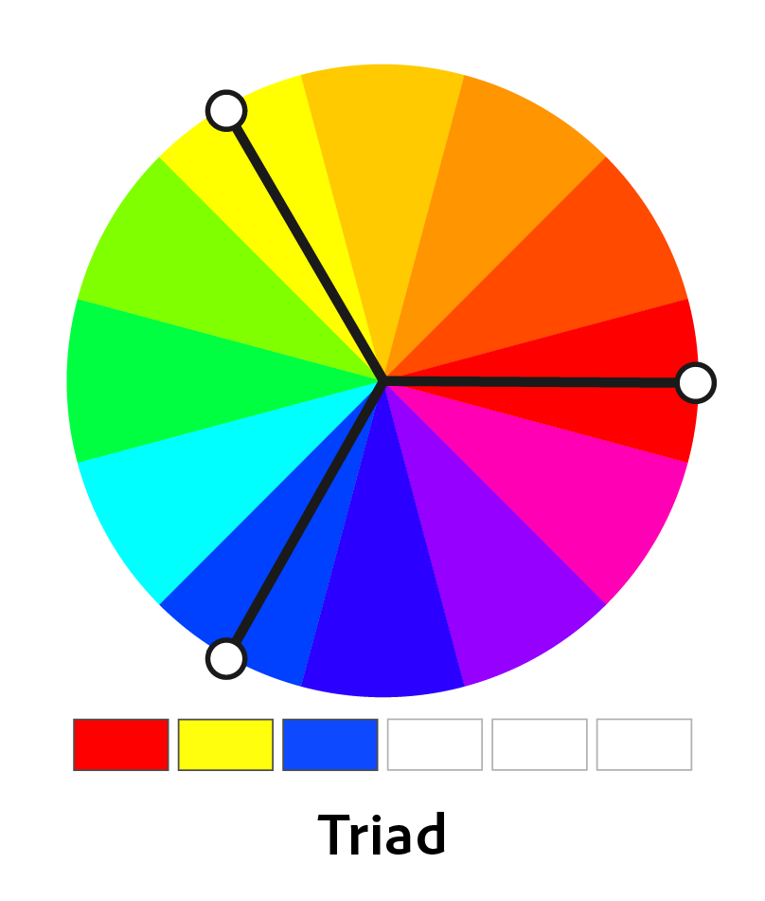

Figure Triadic Color Harmony

Moreover, we can also add saturation and brightness variants into this harmony to create more color schemes with more colors.

##### Tetrads Color Harmony

Tetrads, which means diamond shape, show the color harmony with 2 pairs of complementary colors. The original color generates 3 additional colors hue-rotated by 90 degrees and with a 5% decrease in saturation.

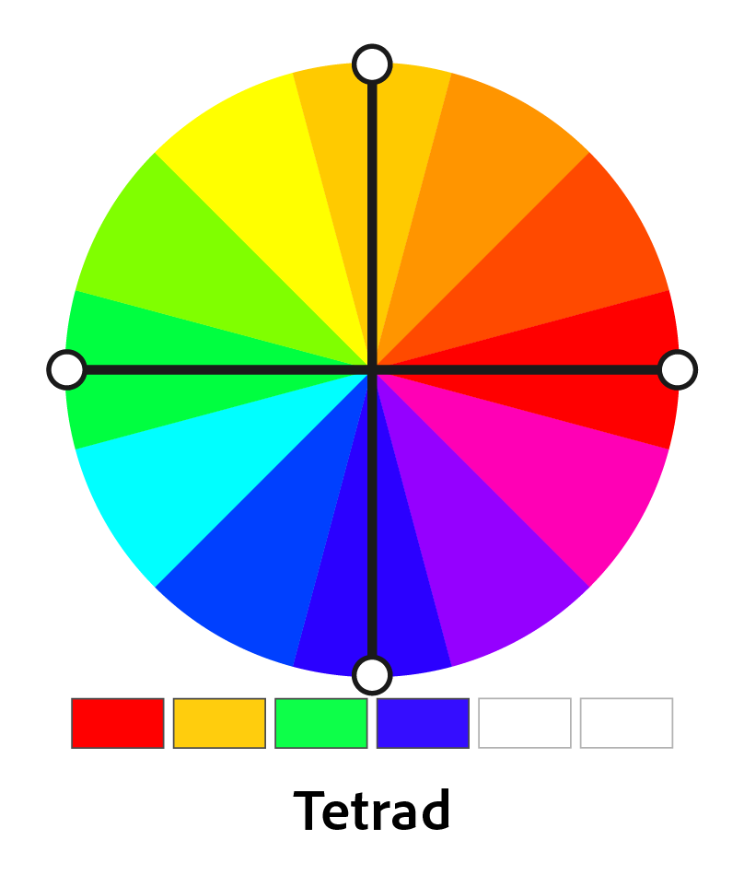

Figure

We can also combine complementary color harmony with this one. For example, one pair of complementary colors can be rotated left or right by 30 or 15 degrees with modulation of the brightness or saturation.

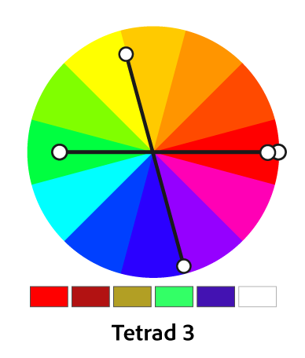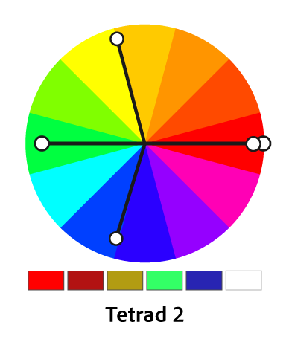

Figure Figure

##### Compounds Color Harmony

This rule consists of analogous and complementaries with clockwise and counter-clockwise variations of each other.

##### High Contrast Color Harmony

High contrast color harmony is based on triad color harmony, but with additional other harmony methods. There are 4 kinds of high contrast color harmony in it.

The first one is a combination of monochromatic variation and left-analogous variation of the original color, with a left complement with brightness or saturation variation, so we can have a 5-color scheme for this rule.

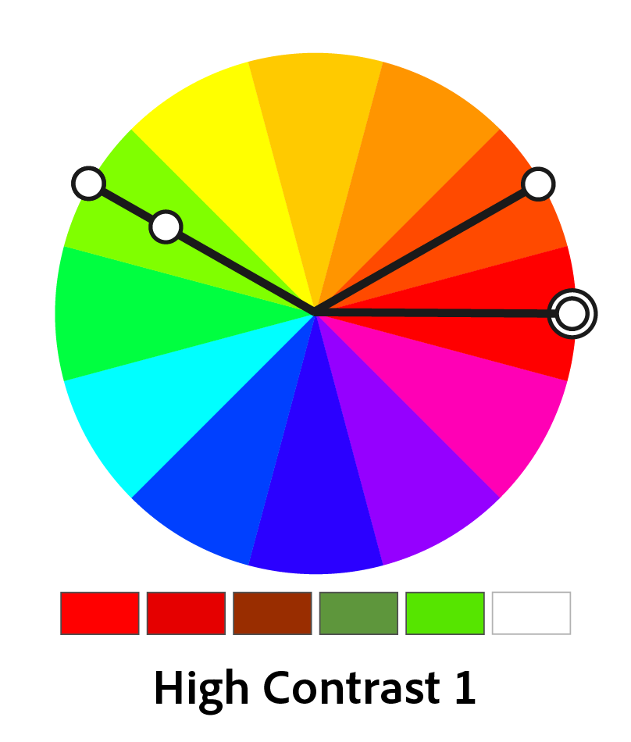

Figure

The only rule goes to a 6-color scheme is the second one. it consists of the basic triad color harmony and the brightness or saturation modulation.

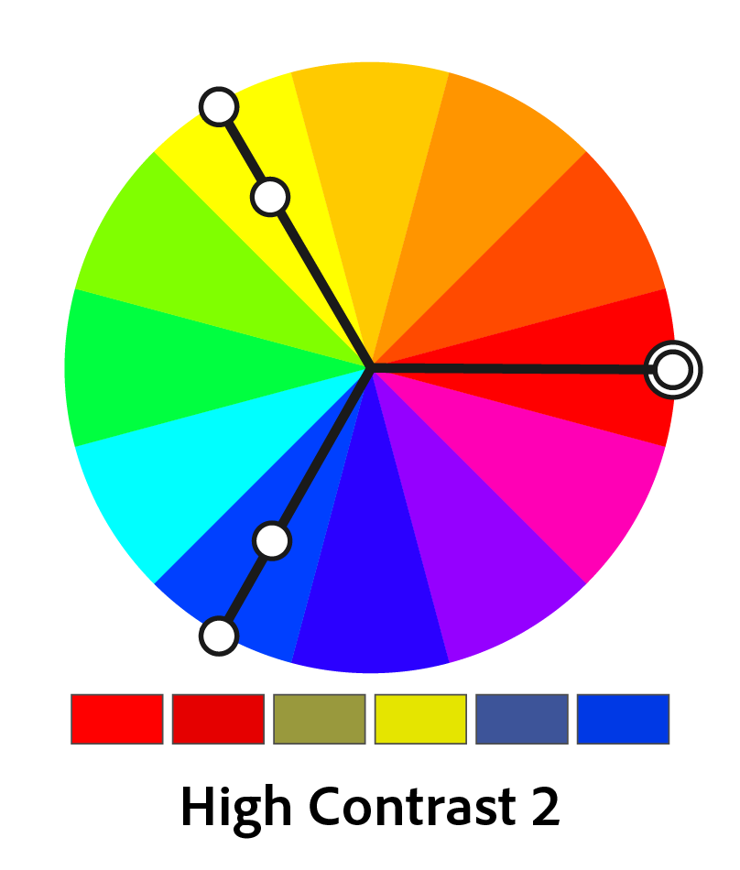

Figure

We can create an analogous variant, along with brightness modulation of this color, with 90-degree counter-clockwise hue variation.

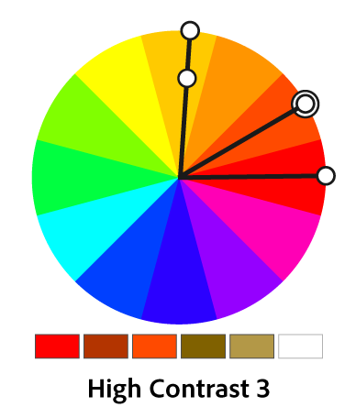

Figure

The last one is similar to the first one. We can change the original color and the rotation direction, producing one more brightness variant based on the new color.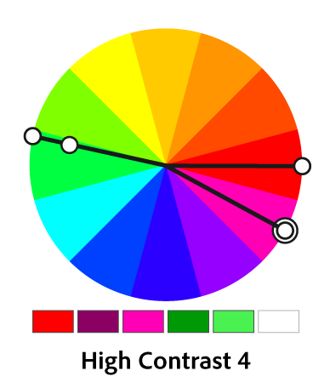

Figure

# Component Design

## Extract Color Theme from Images

### median-cut algorithm

#### Introduction

There are two main steps for implementing median-cut algorithm:

1. Create a “cube” of the colors in the pixels of an image by using each color component (R, G, and B) as an axis (e.g. x, y, z):
   * Calculate the range of each color component (R, G, and B)
   * For the component with the largest range, C, calculate the median value, M
   * Split the “cube” of colors:
     + one cube containing the RGB values of all pixels where the C component is greater than M
     + one cube containing the RGB values of all pixels where the C component is less than M
   * If the number of cubes is equal to our chosen number of desired colors, exit the loop
   * For each color cube, calculate the range of each component, choose the cube which contains the largest range, and repeat
2. For each cube, apply some function (mean, median, mode, etc) to the value of each component, and combine into a new RGB value.

### octree algorithm

### kmeans algorithm

# Human Interface Design

# Requirements Matrix

# Appendices